For Immediate Release
June 27, 2017
Access to View August 21 Eclipse at Bald Knob Cross of Peace
by Advance Ticket Only

Because of the anticipated crowds for the solar eclipse, all individuals can only be admitted to Bald Knob Cross on August 21 with a valid eclipse ticket and parking pass.

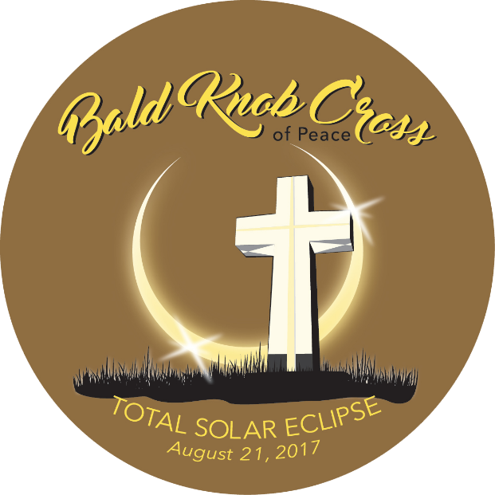
Tickets for the eclipse are still currently on sale and there are spaces still available. Tickets will be sold through August 7th.
The point of greatest duration, the location where the total eclipse lasts the longest along the entire path, is in the heart of southern Illinois, where Bald Knob Cross is located, and Bald Knob Mountain is the highest point in the area, at 1034 feet above sea level.
There are two types of tickets depending on viewing preferences. Serious Viewers can park on-site and have a 10x10 area to set up telescopes and camera equipment. This package is $250 and includes Eclipse classes, a T-shirt and other amenities. Casual Viewers tickets are $50 per person. Shuttle to the Cross will be provided as well as viewing glasses, a T-shirt and additional items. Ticket details and purchase options can be viewed here, http://www.baldknobcross.com/solar-eclipse/tickets, or call 618-713-8516.
Bald Knob Cross of Peace Executive Director Teresa Gilbert states, “There has been a great amount of interest shown in our ‘spot on’ location for the only 360 degree, unobstructed viewing of this rare eclipse. We’re working with the Solar Eclipse Committees, and three local organizations, Egyptian Area Board of Realtors, In The Wind Ministries, and Murphysboro Key Club, are partnering with us to plan this incredible event. Suffice it to say that Bald Knob Cross will be a very popular spot for viewing this phenomenon.”
It is critical that the community know that, for this event, it will not be possible to drive up to the cross without a ticket and parking pass. This is contrary to standard procedures for Bald Knob Cross, where the gate is open 7 days per week and visitors are welcome to come and go at their leisure. We hope you will make plans to join us, but be sure and access your tickets in advance!
-------------------------------------
PERMISSION IS GRANTED TO REPRINT THIS RELEASE PARTIALLY OR IN ITS ENTIRETY
Please add this event to your community calendar.
Thank you for your support.
Questions regarding this release may be directed to:
Teresa Gilbert, Executive Director
Bald Knob Cross of Peace
director@baldknobcross.com
(618) 521-1917 (do not print this phone number; phone number contact for public is listed above)
A page has been created for media/press only that you can access additional information:
http://www.baldknobcross.com/press/

